

MIN PROJECT: AUTO MEASURE SOIL MOISTURE CONTENT

IMPLEMENTED BY:

MUSHIMIYIMANA Emmanuel

April 17, 2022

emmanuelmushg@gmail.com

UWERA Secondine

From IPRC MUSANZE

ELECTRICAL AND ELECTRONICS ENGNEERING DEPERTMENT

YEAR THREE

2021/2022

We are in digital and smart world where everything is done in simplifiedway this is result of good education improvement.

This digital technology is shared in different field of life even in agriculture

That why as engineering student we bring simple technology which will helps people to know condition of their soil by knowing the quantity of water containing in it

The further detail about this is in next pages.

# Abstract

This is simple project which will helps people to know moisture content of their soil (i.ethe level of water contained in their soil).

Here we use electronics devices which are able to communicate with person to tell the soil condition

FC-28 soil moisture sensor is device which plugged into the soil to measure the level of water in the soil

Then it send data to the Arduino board to be analyzed according to instruction given by person

Then after knowing soil condition the extra tools can be commanded by Arduino signal

To pour water in that soil if its water level is low or stop pouring water if soil is getting enough water

But here we used buzzer to inform that the level of water in soil is less

And we used liquid crystal display to show readings of soil condition

The extra tools spoken can be like water pump, pipes in order to make automatic irrigation such as in garden, crops farming etc

So this simple controlling machine is operated by low power of 5v dc

And it achieve greater work.

# Problem statement

All crops need water for certain level in order to grow well and we know sometime the time of sun can be too long and cause soil water content to be low which can result to the drying of crops planted in that soil

So to solve this question the irrigation technic was established but it is difficult to be there always in order to see if water in soil reduced or if it is enough

Especial in land which is far away from where people live or in garden located in cities we cannot get a person who can stand there day and night to check soil condition.

As engineering student we thought about that issue and we design a system which will helps us to know soil condition without reaching there

We used electronic devices which will give us exact answers about if soil is dray or wet

Buzzer is there to tells us that soil water content is low then we can take decision of pouring water in it.

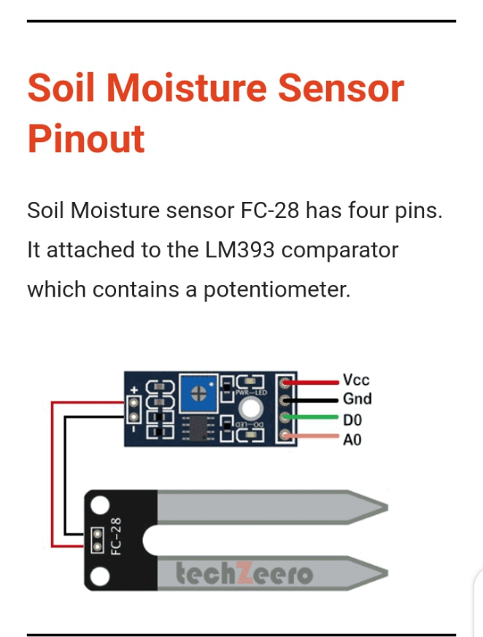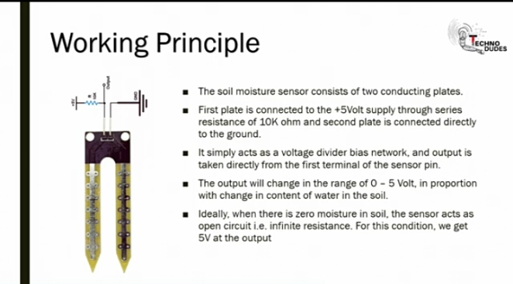

BLOCK DIAGRAM

LCD

ARDUINO UNO

COMPRATOR MODULE

SENSOR IN SOIL

Arduino uno source code for this system

#include<LiquidCrystal.h>

const int rs = 12, en = 11, d4 = 5, d5 = 4, d6 = 3, d7 = 2;

LiquidCrystallcd(rs, en, d4, d5, d6, d7);

int analogdata=A0;

int buzzerpin=8;

int value=0;

int threshold=70;

void setup(){

pinMode(8,OUTPUT);

pinMode(A0,INPUT);

lcd.begin(16, 2);

Serial.begin(9600);

}

void loop() {

value=analogRead(A0);

value=map(value,0,1023,0,100);

if(value>threshold){

lcd.print("SOIL IS GETING DRAY");

digitalWrite(8,HIGH);

}

else{

lcd.print("SOIL GET ENOUGH WATER");

digitalWrite(8,LOW);

}

delay(500);

RUNNING CIRCUIT IN PROTOUS



Image in fritzing

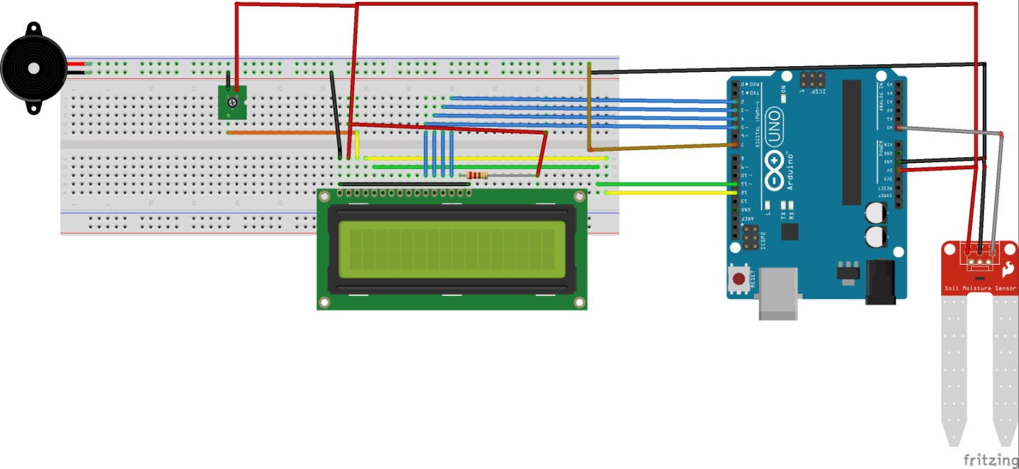

**REFERENCE**

[1] R. auto;atic watering syste;,” vol. 8, no. 2, pp. 372–376, 2018.

[2] I. Engineering, irrigation tion technology,” no. November 2017.

[3] E. Of and E. A. Fan, “D EVELOPMENT OF A RDUINO BASED CONTROL SYSTEM,” vol. 6, no. 8, pp. 378–389, 2018.